Before Pre-Processing:

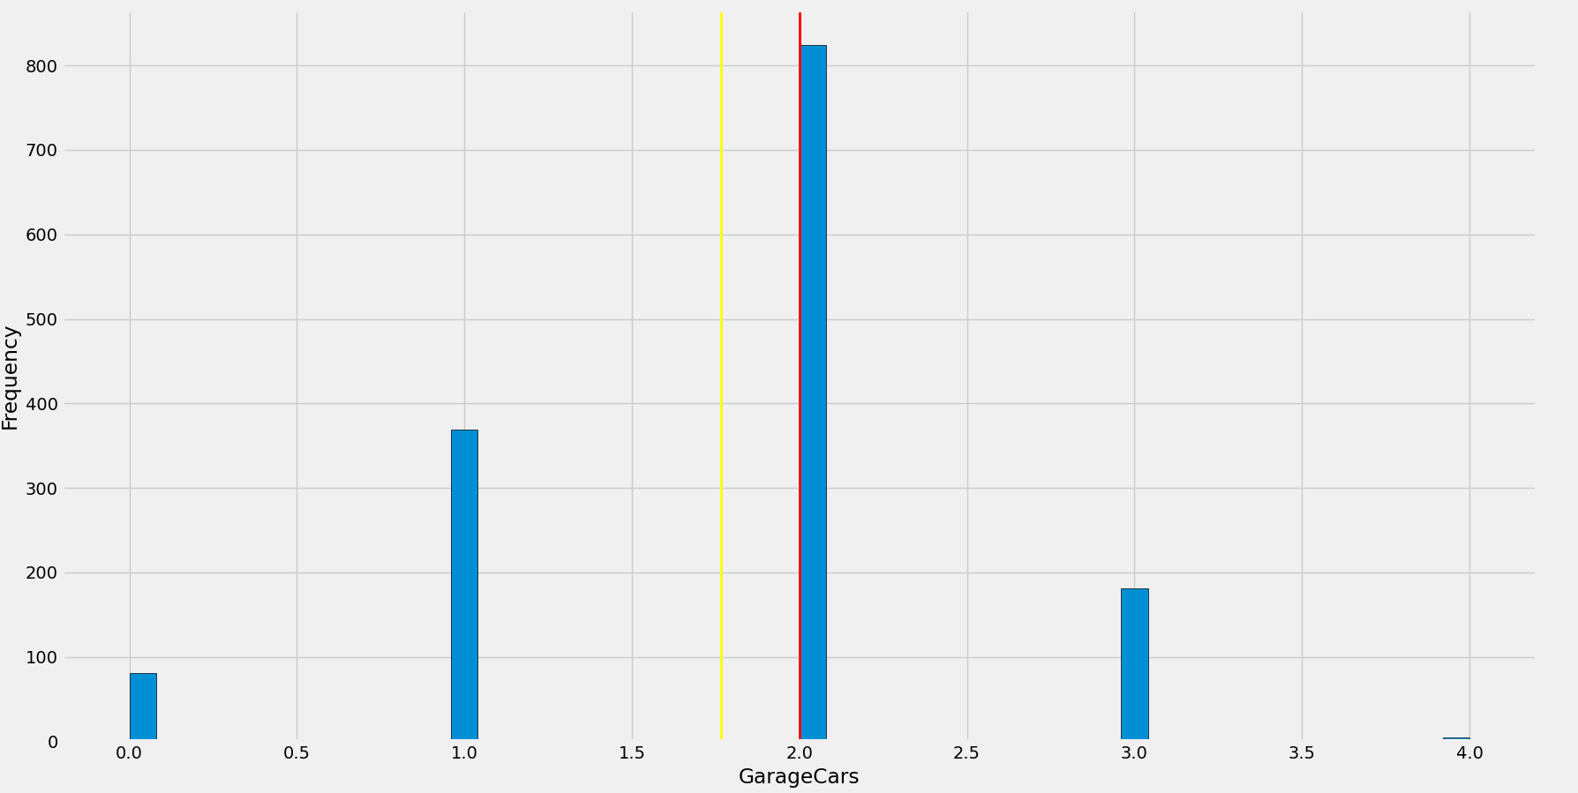

count 1460.000000

mean 1.767123

std 0.747315

min 0.000000

25% 1.000000

50% 2.000000

75% 2.000000

max 4.000000

Skew: -0.3425489297486655

Kurtosis: 0.22099776396532844

**Very less skewness and kurtosis no need to transform**